DENT90151 Advanced Dental Practice
Standardised Case-Based Discussion - Oral Medicine, Oral Surgery
Date: Monday 12th October 2026
Combined reading time: 20 minutes
Combined assessment time: 20 minutes

Oral Medicine
Questions: 9
Reading time: 10 minutes
Oral assessment time: 10 minutes
Changeover/marking time: 10 minutes

Case Scenario 1

A 63-year-old patient presents with an ulcer that has been present for at least six weeks, on the right lateral tongue. The ulcer has not resolved after their denture was adjusted two weeks ago.
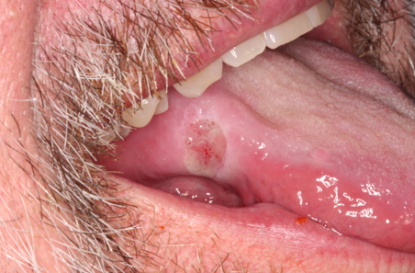
- What is concerning to you in the provided images and history? (2 points)
  - Identifies persistence beyond 2–3 weeks. (0.5)
  - Recognizes lateral tongue site – high risk of oral cancer (0.5)
  - Failure to resolve after removing trauma. (0.5)
  - Recognizes keratotic raised margins, induration, pain or risk factors. (0.5)
- What further information do you require, and how you will collect it (2 points)
  - Oral Cancer risk factors – smoking, ethanol, betel quid, ethanol containing mouthwash (0.5)
  - Asks about duration, change in size, pain, bleeding, altered sensation, dysphagia, speech or eating difficulty, and weight loss. (0.5)
  - Asks about local trauma, denture fit, sharp teeth/restorations, previous adjustment, and whether the ulcer improved after the cause was removed. (0.5)
  - Collects information by full oral mucosal examination, palpation for induration/fixation, assessment of cervical lymph nodes, and documentation with clinical photographs and measurements. (0.5)
- What are your differential diagnoses? (2 points)
  - Oral squamous cell carcinoma must be considered/highly suspected because the ulcer is persistent, on the lateral tongue, and has not resolved after denture adjustment. (0.5)
  - TUGSE remains a differential diagnosis because it can present as a chronic traumatic tongue ulcer and mimic malignancy clinically. (0.5)
  - IF says that TUGSE stands for – Traumatic Ulcerative Granuloma with Stromal Eosinophilia (0.5)
  - Other differentials include chronic traumatic ulcer, aphthous-type ulcer, infectious ulcer or less common immune-mediated ulceration, but persistence means malignancy must be excluded first. (0.5)
- Can you communicate your next steps to me as if I am the patient? (2 points)
  - Uses plain language in role play (0.5)
  - Explains that the ulcer has not healed as expected. (0.5)
  - Explains that specialist review or biopsy is needed to confirm the diagnosis. (0.5)
  - Explains urgency without causing undue alarm. (0.5)
  - Confirms plan for follow-up and safety-netting. (0.5)

Section /8

Case Scenario 2
A 74-year-old edentulous patient presents with a small papillary growth on the right mandibular alveolar ridge. She noticed this while cleaning her denture three months ago.
Photo: 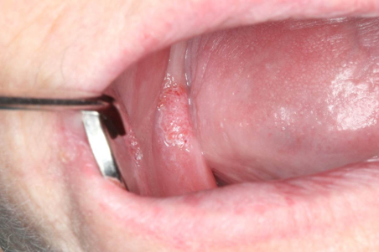

- What is concerning to you in the provided images and history? (2 points)
  - Identifies a small papillary/verruciform growth on the right mandibular alveolar ridge in an edentulous patient. (0.5)
  - Recognizes that the lesion has persisted for several months, which makes a transient traumatic or inflammatory lesion less likely. (0.5)
  - Notes the denture-related context but does not assume trauma alone; as it is a persistent papillary lesions (0.5)
  - Noted the age of the patient (0.5)
- What further information do you require about the patient and the lesion, and how will you collect it? (2 points)
  - Medical history, hx of immunocompromise, smoking, Ethanol (0.5)
  - Asks about onset, growth, symptoms, recurrence, previous cutaneous warts or other lesions, other mucosal sites (0.5)
  - Perform palpation of lymph nodes and full oral mucosal examination to check for other papillary, verrucous, ulcerated or white/red lesions. Palpate the lesion and surrounding tissues for tenderness, induration, fixation, ulceration or bleeding (0.5)
  - Assess denture fit, denture hygiene and local trauma, (0.5)
- What are your differential diagnoses?
  - Verruca vulgaris (0.5)
  - Squamous papilloma. (0.5)
  - Includes fibroepithelial polyp or denture related hyperplasia (0.5)
  - Mentions verrucous carcinoma or conventional squamous cell carcinoma (0.5)
- What is the human papilloma virus and is it dangerous? (2 points)
  - States that human papillomavirus are a family of viruses that infects stratified squamous epithelium of skin and mucosa. (0.5)
  - Explains that most HPV types are low-risk and ubiquitous may cause benign papillary lesions such as squamous papilloma, verruca vulgaris or condyloma acuminatum. (0.5)
  - Explains that high-risk HPV types are associated with some cancers, particularly cervical and oropharyngeal squamous cell carcinoma, but are not the usual explanation for a small isolated oral verruca-like lesion. (0.5)
  - States that HPV vaccination is part of the vaccination schedule and so risk is less likely for individual who have received the vaccination (<45 year) (0.5)
- Can you communicate your next steps to me as if I am the patient? (2 points)
  - Uses plain language in role play (0.5)
  - Explains that the growth needs assessment because it has persisted. (0.5)
  - Explains that removal or biopsy may be needed to confirm the diagnosis. (0.5)
  - Describes denture review, oral hygiene advice and follow-up. (0.5)

Section /10

Global Rating Scale
Excellent
Good
Satisfactory
Borderline
Unsatisfactory

Oral Surgery
Questions: 9
Reading time: 10 minutes
Oral assessment time: 10 minutes
Changeover/marking time: 10 minutes

Case Scenario
A 35-year-old otherwise healthy female presents with a 3-day history of increasing pain and swelling of the left lower jaw. She has fever (38.5°C), difficulty opening her mouth (trismus), and dysphagia. The swelling is firm, tender, and extends below the angle of the mandible. There is a carious lower left first molar.

Medical History: nil significant
Medications: nil regular
Allergies: penicillin – rash

Extra-oral photograph and OPG:
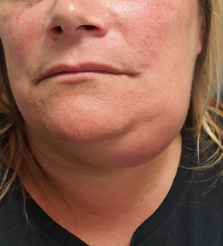

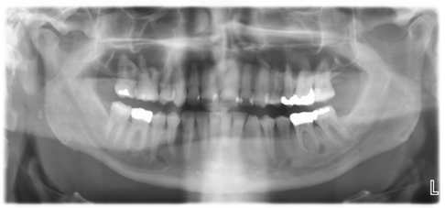

Section A - Clinical Assessment
- What is the provisional diagnosis?
- What clinical signs of airway compromise would concern you in this case?
- What clinical signs might indicate imminent airway compromise?

Section B - Pathophysiology
- Does the infection involve primary or secondary fascial spaces?
- What antibiotic could be prescribed for this patient and why?
- What is the difference between cellulitis and abscess?

Section C - Management - Communication/referral
- How would you manage and coordinate care for this patient?
- If you decide to refer, what information would you include in your referral?
- What treatment might the patient have with the receiving specialist?

Oral Surgery Marking Rubric

Section A - Clinical Assessment
- What is the provisional diagnosis?
Excellent | Correctly states left submandibular abscess, odontogenic in origin, secondary to tooth 36
Borderline | Requires prompting  At minimum: identifies spreading odontogenic infection, submandibular space
Unsatisfactory | Fails to recognise swelling as odontogenic abscess despite prompting, unable to state location

- What clinical signs of airway compromise would concern you in this case?
Excellent | Identifies  - trismus  - dysphagia
Satisfactory | Identifies at least one
Borderline | Requires prompting, identifies at least one
Unsatisfactory | Unable to identify, incorrectly identifies clinical signs relevant to the case

- What clinical signs might indicate imminent airway compromise?
Excellent | Able to name 3 or more clinical signs for imminent airway compromise:  - unable to swallow secretions  - use of accessory muscles  - cyanotic  - unable to lie flat  - posturing  - use of accessory muscles
Satisfactory | Identifies one or two
Borderline | Requires prompting, identifies one or two
Unsatisfactory | Unable to identify, identifies incorrectly

Section B - Pathophysiology
- Does the infection involve primary or secondary fascial spaces?
Excellent | Student correctly states submandibular is a primary fascial space (contiguous with the tooth bearing region)  NB Primary spaces: canine, buccal, submandibular, sublingual, submental  Secondary spaces: sub masseteric, pterygomandibular, lateral pharyngeal, retropharyngeal
Borderline | Able to state primary space with vague or unclear descriptions, requires prompting  Able to describe some related regional anatomy to the submandibular region
Unsatisfactory | Unable to state primary space  Incorrectly describes regional anatomy or differences in fascial spaces

- What antibiotic could be prescribed for this patient and why?
Excellent | Correctly selects a non-penicillin based antibiotic because patient has a penicillin allergy.  - Clindamycin  - Or Cephalexin  - Or Metronidazole  - Uses generic name (ETG guidelines)  Can identify those commonly used in management of odontogenic infections and those that are inappropriate for this patient:  - Penicillin, Amoxicillin, Amoxicillin + Clavulanic acid  Demonstrates some awareness of IV vs. oral routes of administration.
Satisfactory | Correctly selects a non-penicillin based antibiotic because patient has a penicillin allergy
Borderline | Requires prompting  Able to select non-penicillin based antibiotic because patient has a penicillin allergy
Unsatisfactory | Unable to list any appropriate antibiotics by generic name, or selects inappropriate antibiotic:  - Penicillin, Amoxicillin, Amoxicillin + Clavulanic acid

- What is the difference between cellulitis and abscess?
Excellent | Correctly describes difference  - Cellulitis (diffuse, indurated tissue oedema)  - Abscess (organised fluid/pus collection)
Borderline | Describes difference in incomplete or vague terms, requires prompting
Unsatisfactory | Unable to/inaccurately identifies difference between cellulitis and abscess

Section C - Management - Communication/referral
- How would you manage and coordinate care for this patient?
Excellent | Correctly states this patient will require definitive management at a specialist level and describes why (e.g. airway compromise, fever/systemic infection)  Correctly states they will need urgent referral by phone and/or letter either to  - OMS team directly  - Closest tertiary hospital emergency department  Identifies some aspects in their scope:  - Informed consent for referral  - Patient-centered communication  - Appropriate antibiotic prescription with review and communication with OMS team  - Follow up of care
Satisfactory | Correctly states patient will require OMS specialist management and referral
Borderline | Recognises that the patient needs specialist care  Superficial or limited understanding of scope and referral process  Requires prompting
Unsatisfactory | Unable to provide clear management plan, or incorrectly identifies definitive management as within their general scope.  Provides unsafe plan, including:  - Extraction or abscess drainage in outpatient setting  - Prescribes antibiotics alone  - Does not recognize need for surgical care  - Does not recognize need for specialist management

- If you decide to refer, what information would you include in your referral?
Excellent | Clearly and correctly outlines pertinent information about patient to be conveyed over the phone and by referral letter.  May use ISBAR - Identify/Introduction, Situation, Background, Assessment, and Recommendation.  Includes key information:  - Patient details  - Referring clinician’s details  - Details of the department/specialist the referral is being directed to  - Clinical history  - Provisional diagnosis
Satisfactory | Correctly outlines key information
Borderline | Correctly outlines key information, requires prompting
Unsatisfactory | Missing key information  Vague or inaccurate understanding of referral process

- What treatment might the patient have with the receiving specialist?
Excellent
Satisfactory
Borderline
Unsatisfactory

